**CMPE287 – Software Quality Assurance and Testing**

**Lab #1 Assignment**

**First Name:** Harish

**Last Name:** Marepalli

**SJSU ID:** 016707314

**Professor:** Dr. Jerry Gao

Q: Elementool Bug Report

Answer:

1. Screenshot 1 shows the account creation page with my details.

Account Name: 016707314

User Name: HarishM

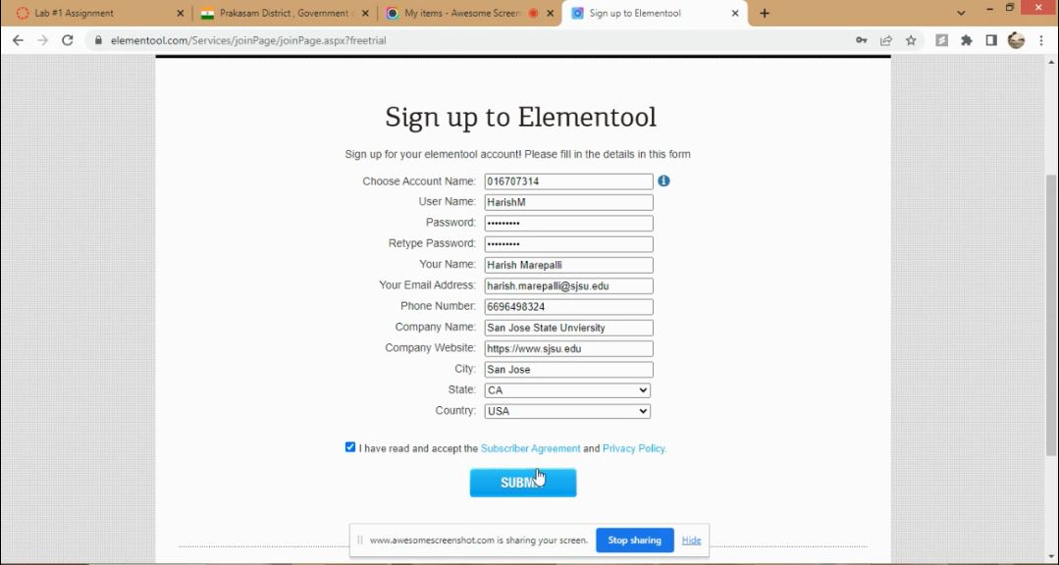

***Screenshot 1***

1. Screenshot 2 shows the account setup confirmation after clicking SUBMIT button.

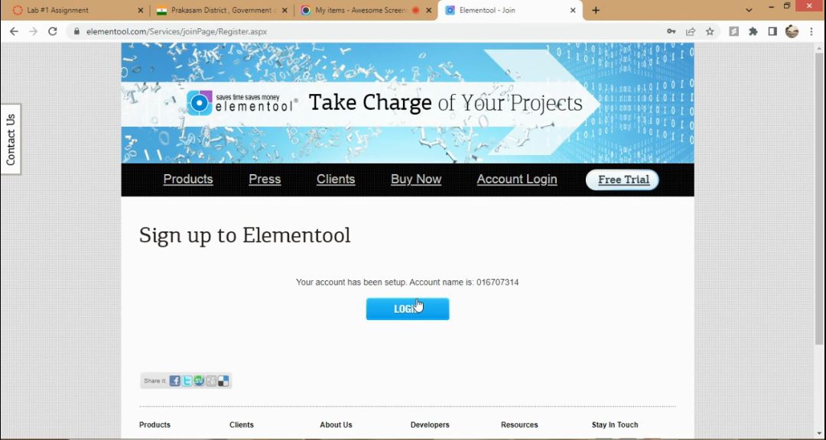

***Screenshot 2***

1. Screenshot 3 shows the Login page provided with credentials.

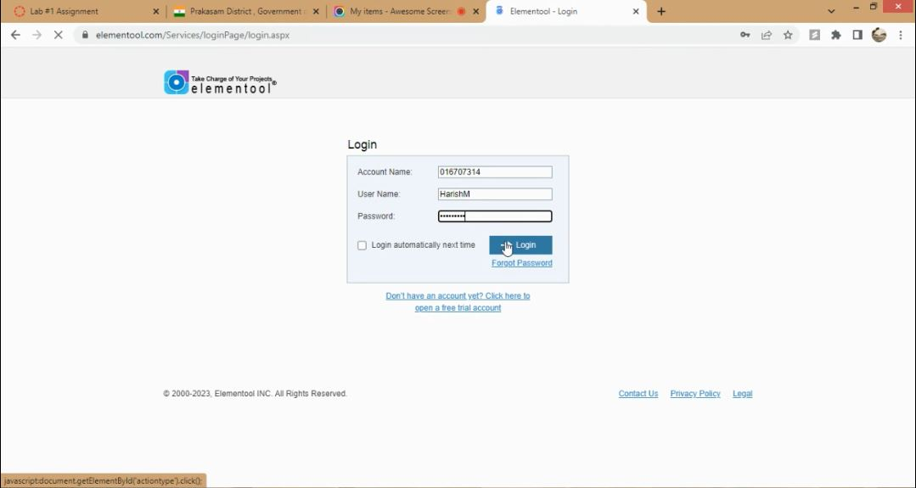

***Screenshot 3***

1. Screenshot 4 shows the home page after logging into Elementool.

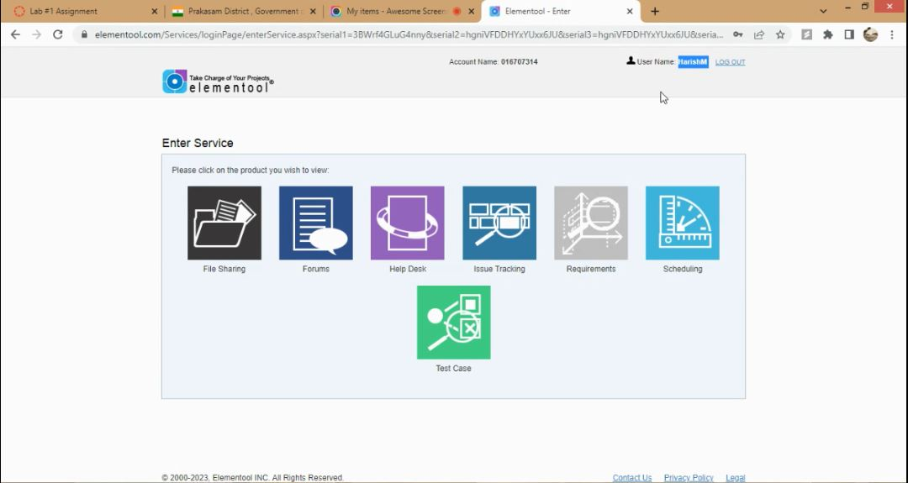

***Screenshot 4***

1. Screenshot 5 shows the Welcome Issue Tracking page, which comes up by clicking Issue Tracking Service.

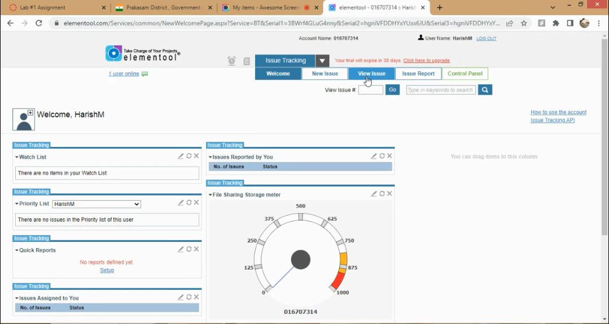

***Screenshot 5***

1. Screenshot 6 shows the New Issue page, which comes up by clicking ‘New Issue’ tab.

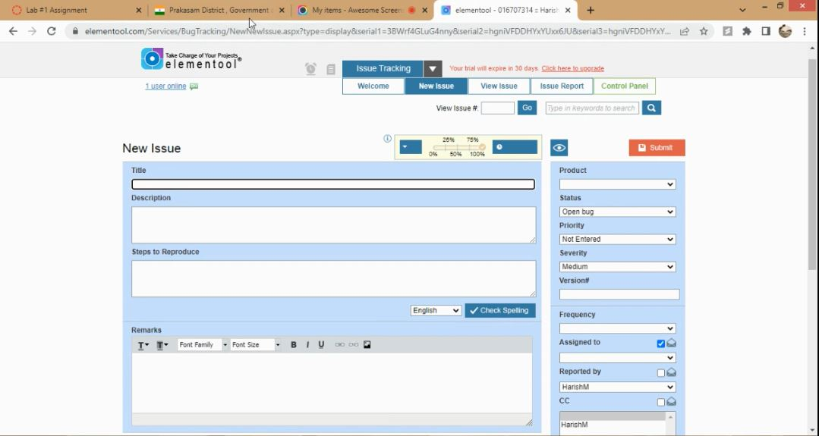

***Screenshot 6***

1. Screenshot 7 shows the Prakasam District website bug, which can be viewed using the link, https://prakasam.ap.gov.in/

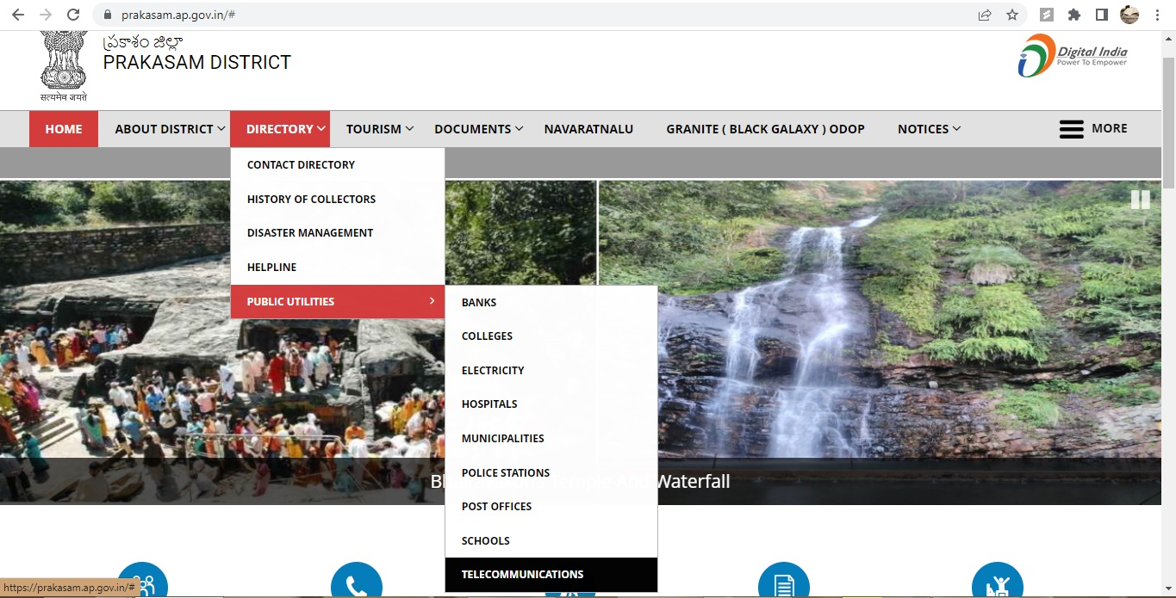

***Screenshot 7***

1. Screenshot 8 shows the New Issue with the issue details recorded.

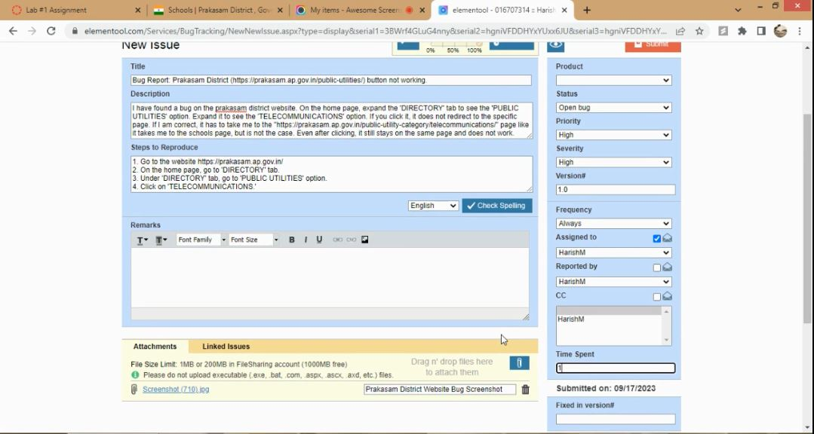

***Screenshot 8***

1. Screenshot 9 shows the confirmation of issue reported which comes up by clicking the Submit button.

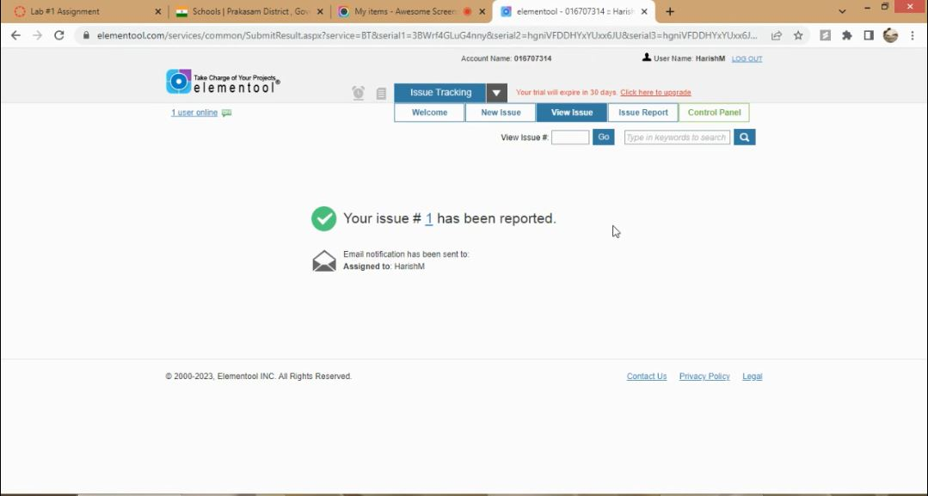

***Screenshot 9***

1. Screenshot 10 shows the recorded Issue 1 that comes up by typing ‘1’ in the View Issue textbox and clicking ‘Go’ button.

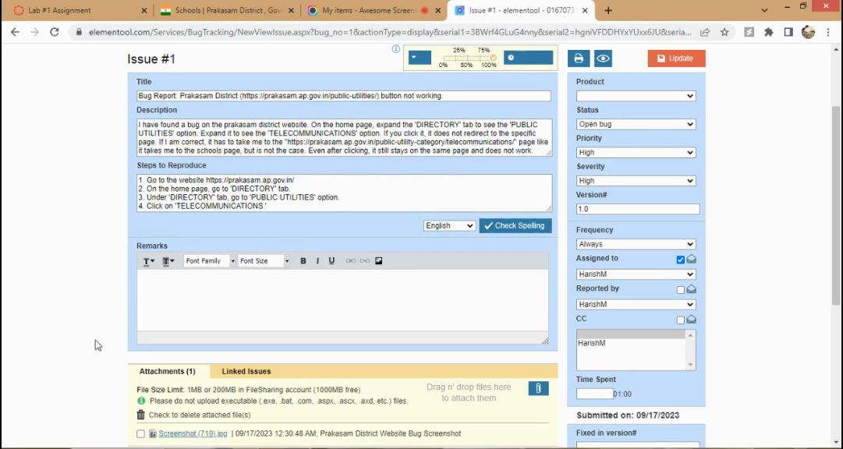

***Screenshot 10***

1. Screenshot 11 shows the History Trail of Issue 1.

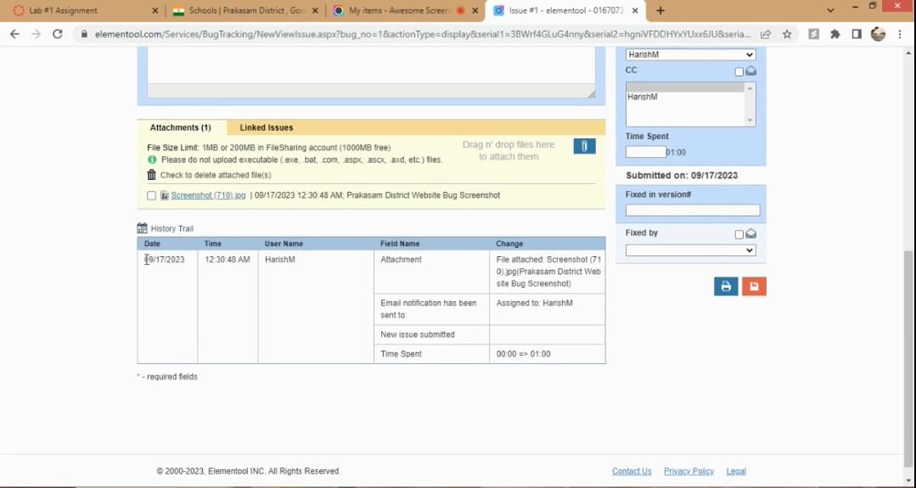

***Screenshot 11***

1. Screenshot 12 shows the Issue Report, which comes up by clicking Issue Report->Display Report. This is a complete bug report.

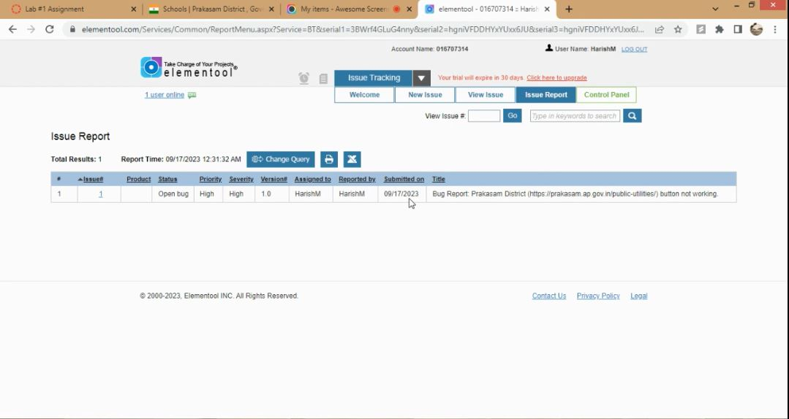

***Screenshot 12***

This concludes the Lab1 assignment.